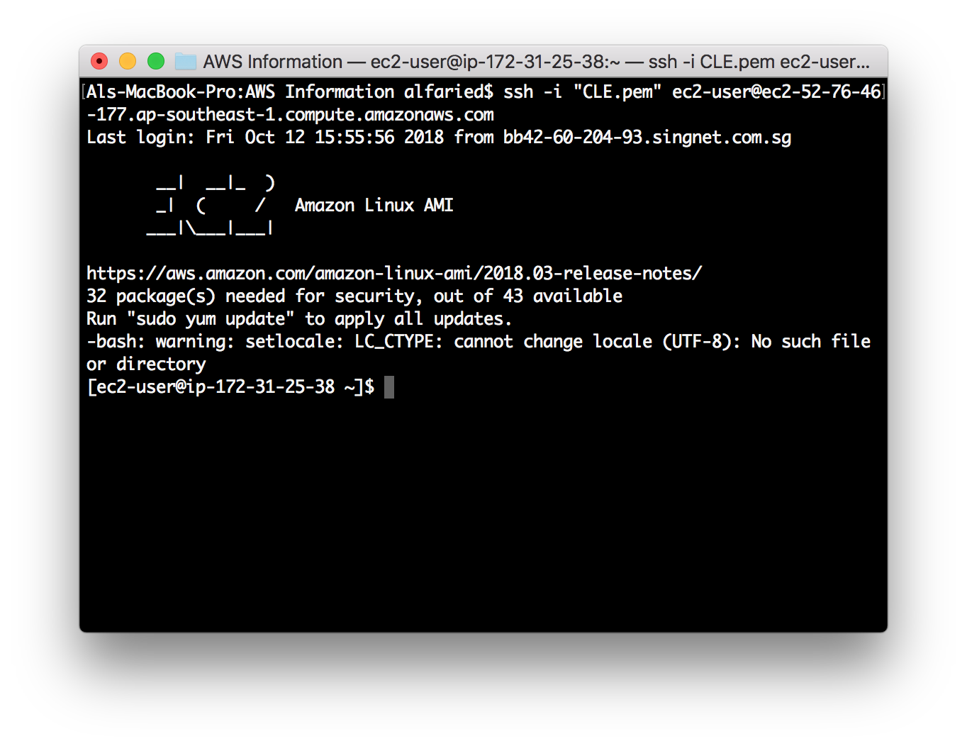

Initialization Step: After you’ve ssh into your instance, you would need to configure the aws details. For that, please move back to your AWS Management Console on your browser.

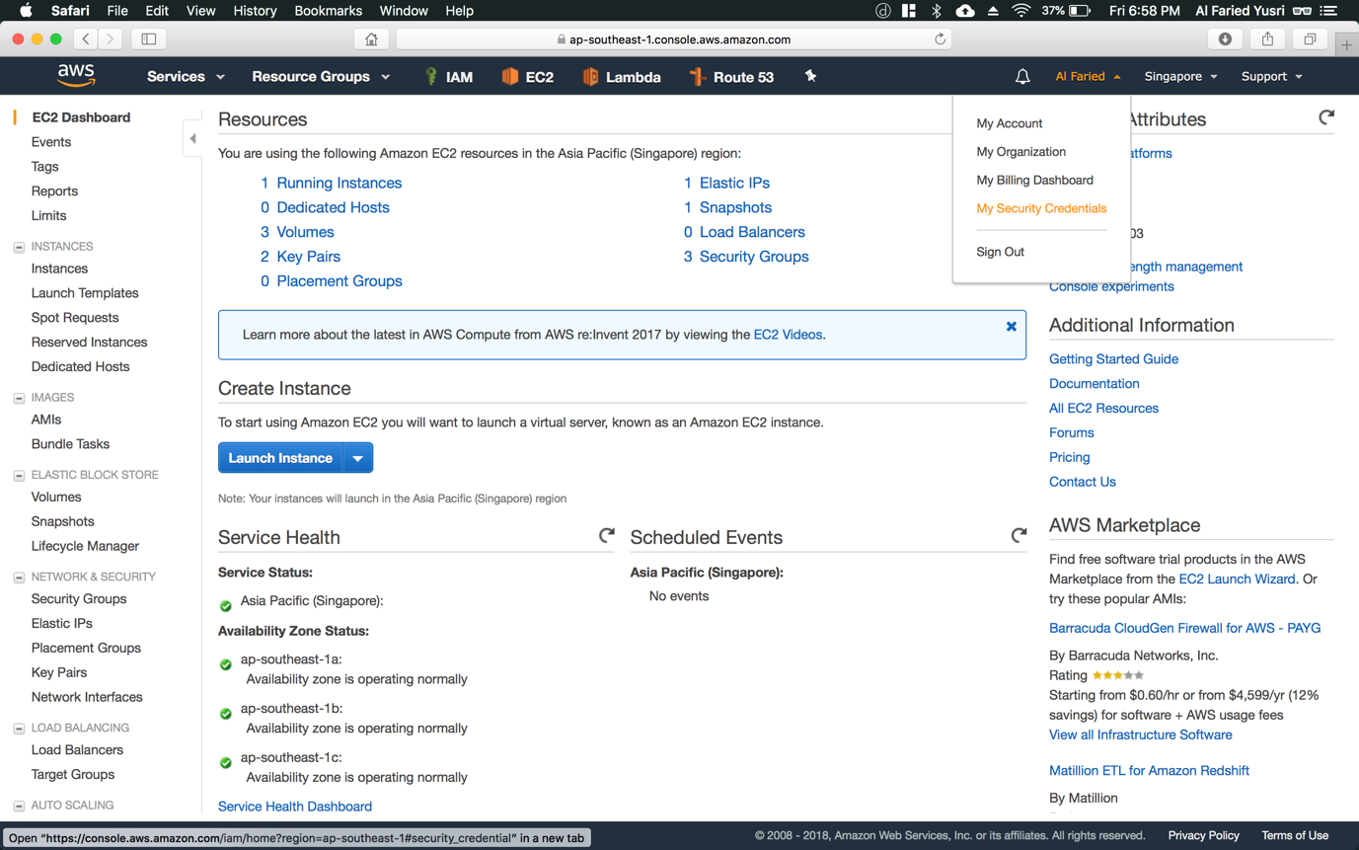

Step 1: Back on the AWS Management Console, click on name, located on the top right hand corner and choose “My Security Credentials” from the drop-down list

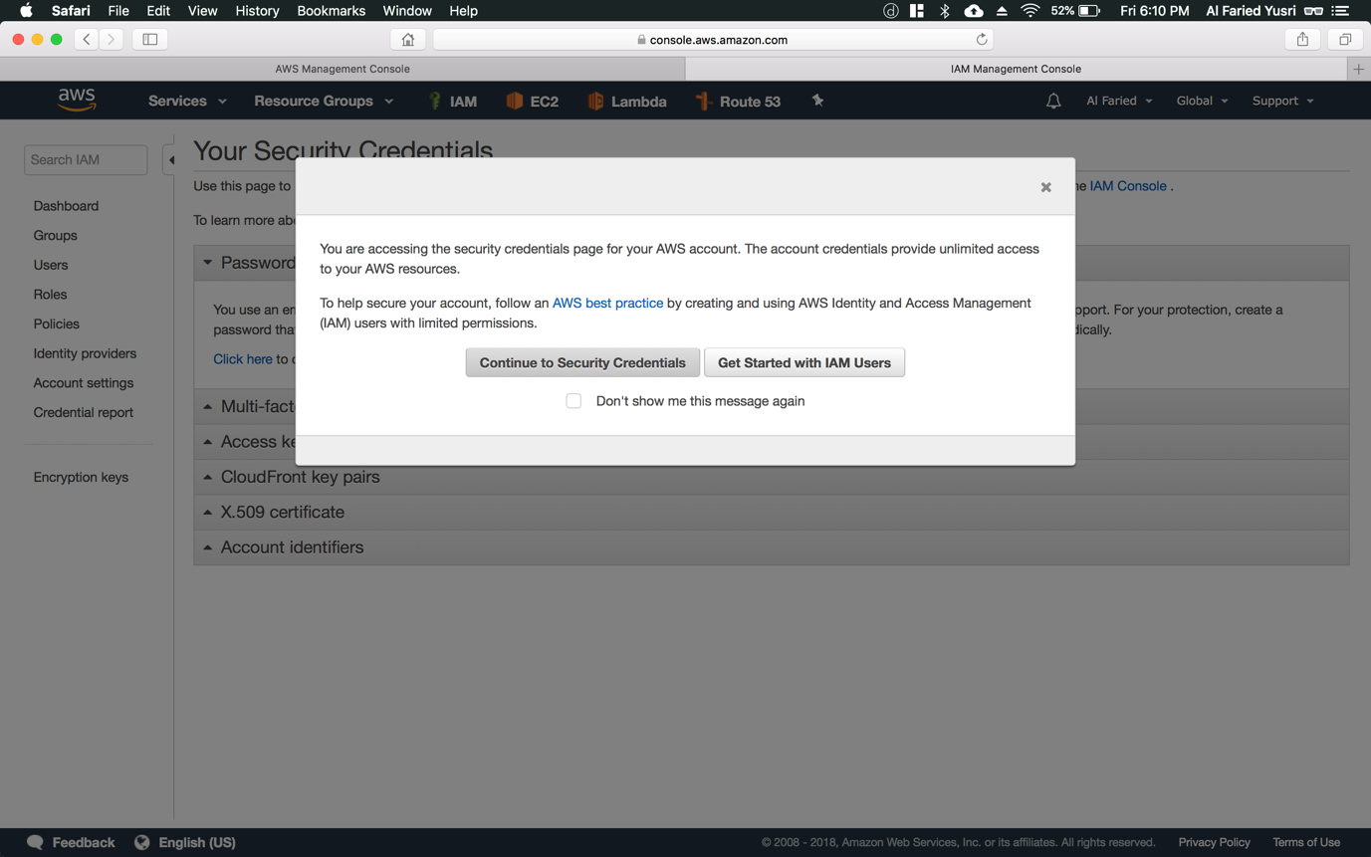

Step 2: When greeted with this page, choose “Continue to Security Credentials”

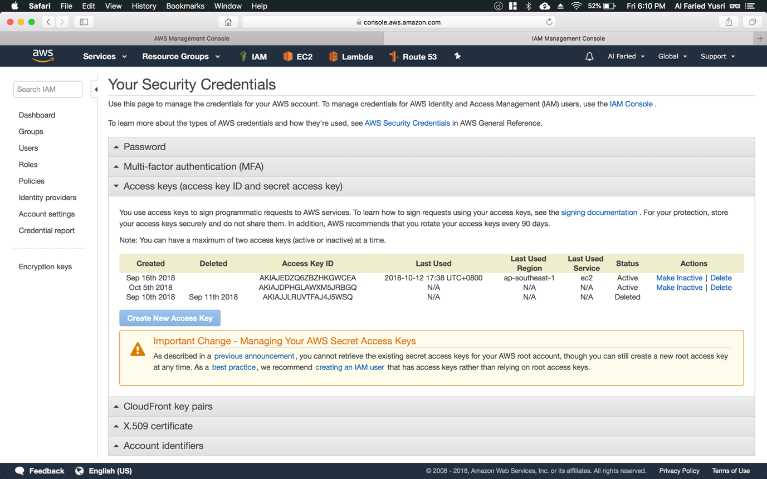

Step 3: Choose the “Access keys (access key ID and secret access key)” tab and click on “Create New Access Key” button (refer to Figure 1.1)

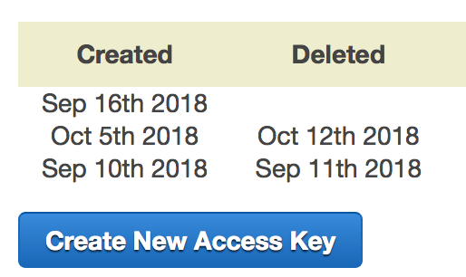

Figure 1.1

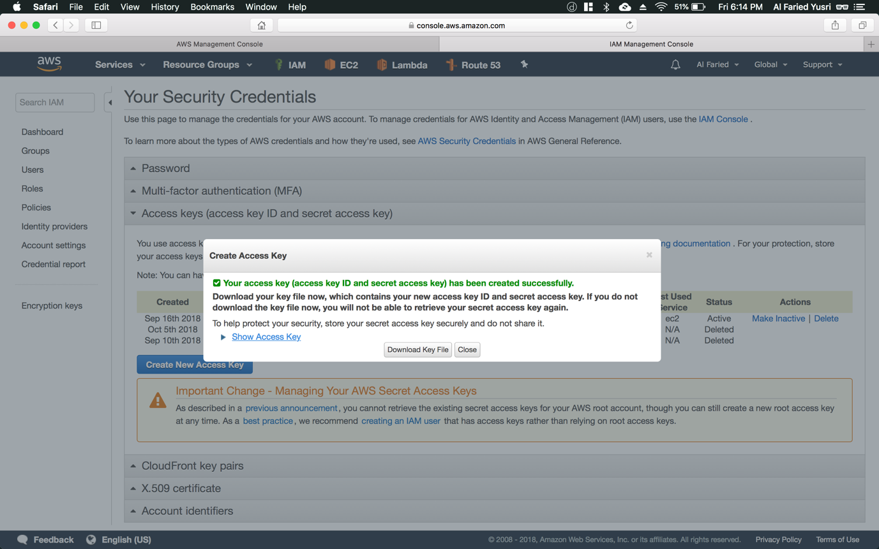

Step 4: Click on “Show Access Key” option to retrieve your access key and secret access key

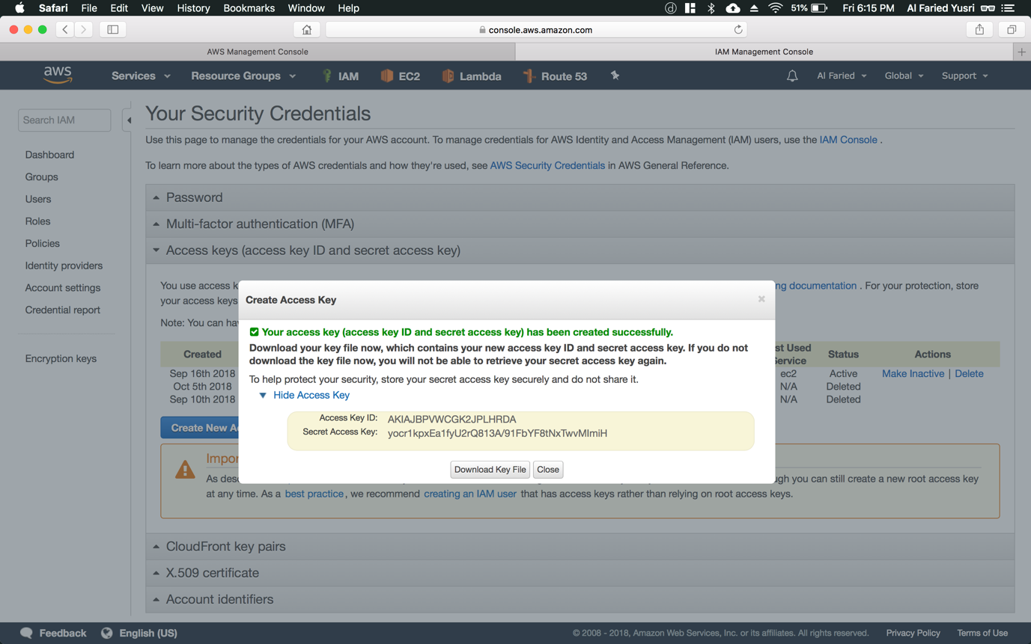

Step 5: Once greeted with this, copy the Access Key ID (refer to Figure 2.1) and Secret Access Key (refer to Figure 2.2) or click on the “Download Key File” button



Figure 2.1



Figure 2.2

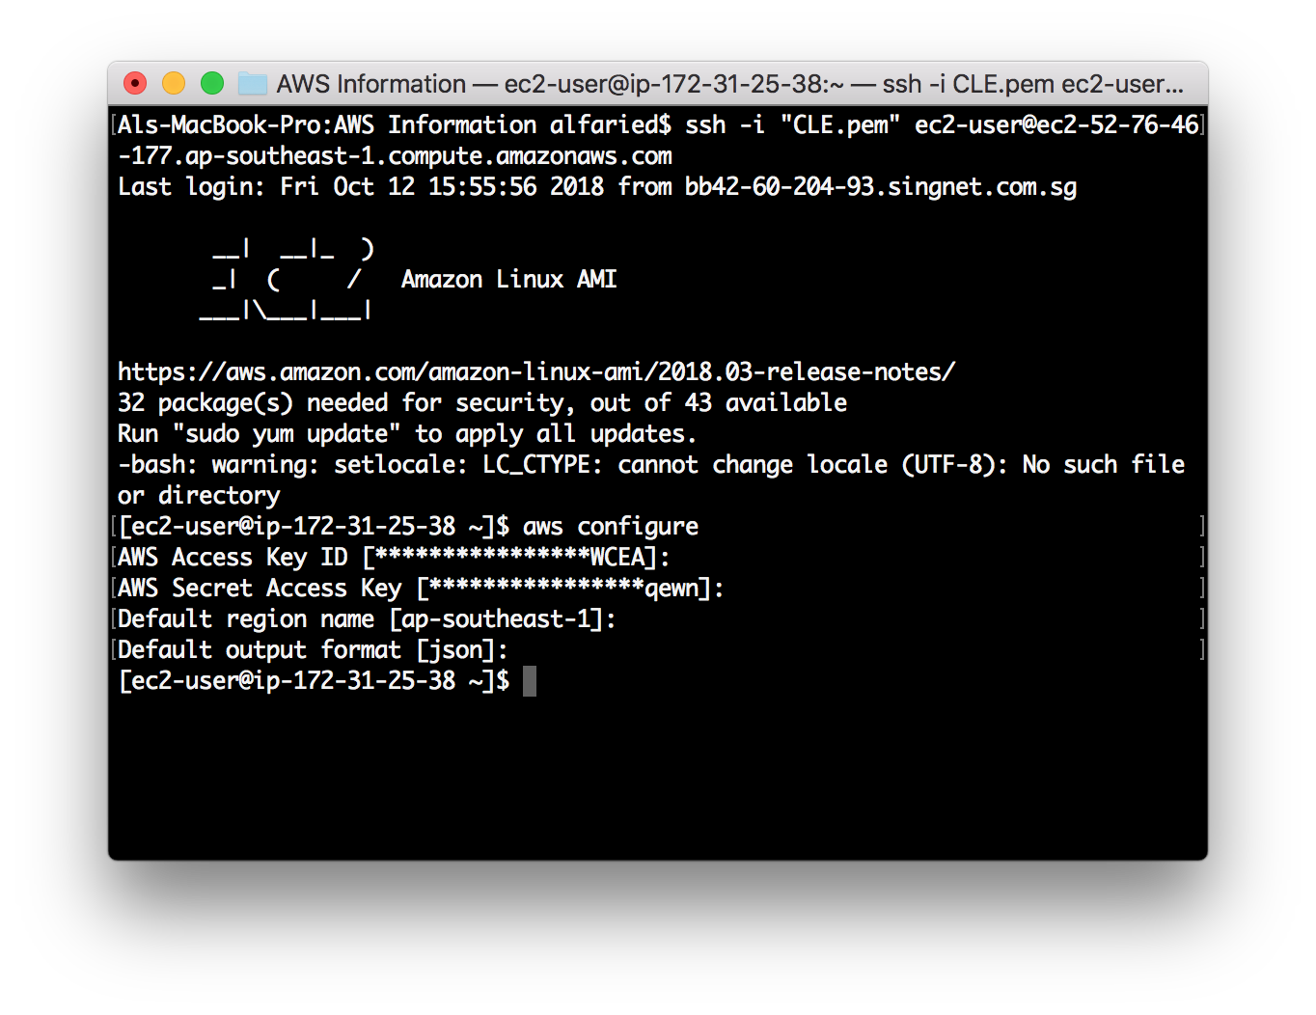

Step 6: Return back to your terminal/command prompt with the server ssh-ed into and type command “aws configure”. Next paste your Access Key ID and Secret Access Key that you’ve copied or saved, somewhere on your computer from the previous step. Additionally, enter “ap-southeast-1” and “json” for your default region name and output format respectively

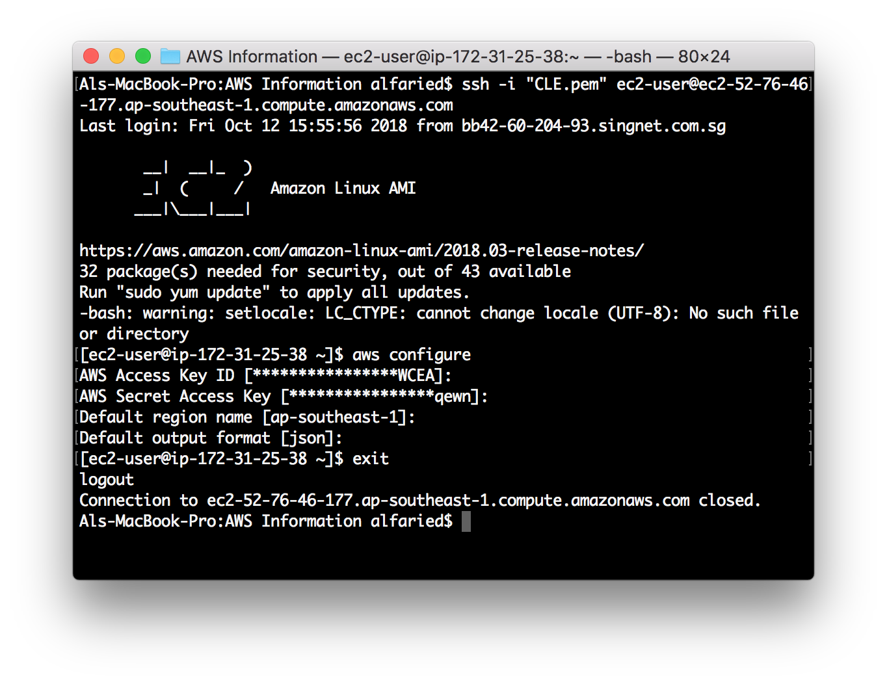

Step 7: Then type “exit” to logout from the server which you’ve ssh-ed into

*\*Please refer to the next set of instructions on how to associate an elastic IP to your instance and restart it*